PERTH MODERN SCHOOL


UNIT 3C/3D MAS – 2011

TEST 1 – POLAR COORDINATES & COMPLEX NUMBERS

NAME: SOLUTIONS DATE: 9/10 February, 2011

[To achieve full marks and to allow assessment of particular outcomes, working and reasoning should be shown.]
[A maximum of 2 marks will be deducted for incorrect rounding, units, etc.]

This is Resource Rich – 50 minutes for 53 marks:

- [1, 1, 1, 1 = 4 marks]
Convert:
  - (4,-6) into polar coordinates with -180° < θ ≤ 180°.

toPol([4,-6]) ⇒ [7.21, -56.3°] ✓

  - (3,- 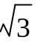) into exact polar coordinates with -π < θ ≤ π.

toPol([3,- 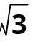]) ⇒ [2 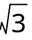, 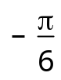 ] ✓

  - [4,35°] into Cartesian coordinates.

toRect([4,∠35°]) ⇒ (3.28, 2.29) ✓

  - [8,-¾π] into exact Cartesian coordinates.

toRect([8,∠-¾π]) ⇒ (-4 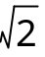, -4 ) ✓

- [3, 3 = 6 marks]
Clearly show how you obtain your answers, find:
  - the distance between [20,-210°] and [ 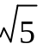,-50°].

toRect([20,∠(-210°)]) ⇒ (-17.32, -10) ✓
toRect([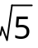,∠(-50°)]) ⇒ (1.44, -1.71) ✓
norm([-17.32, -10] – [1.44, -1.71]) ⇒ 22.11 ✓

  - the exact distance between 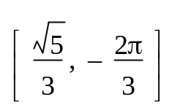and 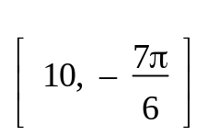.

toRect([ 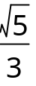,∠( 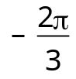)]) ⇒ (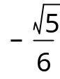 , 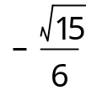 ) ✓
toRect([10,∠( 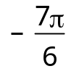)]) ⇒ (-5 , 5) ✓
norm([ , ] – [-5 , 5]) ⇒ 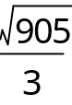 ✓

- [8 marks]
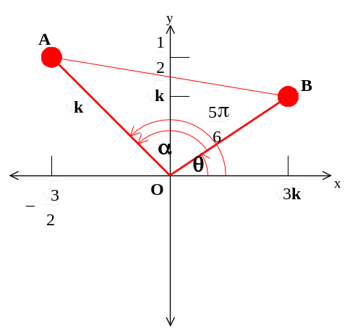Find the exact distance between ( 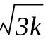, 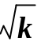) and 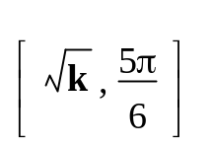. Draw a diagram.
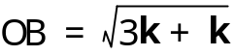
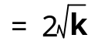 ✓
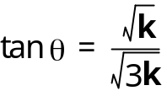 ✓
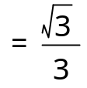
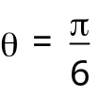 ✓ ✓
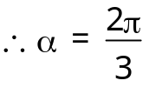 ✓
AB² = OA² + OB² – 2(OA)(OB) cos α ✓
= k + 4k – 2()(2 )(-½)
= 7k ✓
∴ AB = 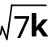
∴ The distance between the points is units. ✓
- [3, 2 = 5 marks]
  - Find, in exact form, the modulus and principal argument of - + i, and hence rewrite - + i in exact polar (cis) form.

Modulus = 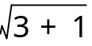 = 2 ✓
Principal argument = tan⁻¹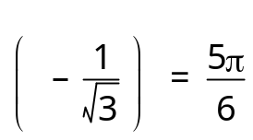 ✓
∴ - + i = 2 cis 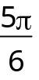 ✓

  - Convert 2 cis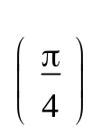into exact algebraic Cartesian/rectangular form.
2 cis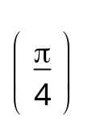= 2 cos + i sin ✓
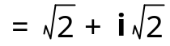 ✓

- [3, 3 = 6 marks]
Evaluate, giving answers in exact form:
  - 4 cis × 2 cis 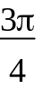 = 8 cis 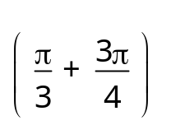 ✓
= 8 cis 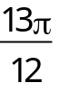 ✓
= 8 cis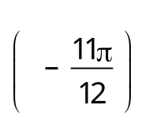 ✓

  - 4 cis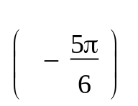
= 2 cis 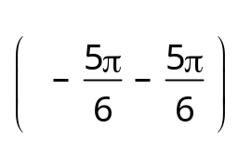 ✓
= 2 cis 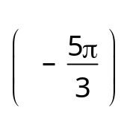 ✓
= 2 cis 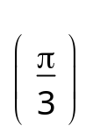 ✓
2 cis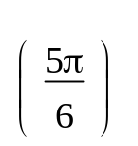

- [4 marks]
Given z = 2 cis , express z⁻¹ and in exact polar and rectangular form.

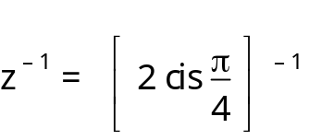
= ½ cis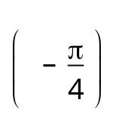 ← Polar form ✓
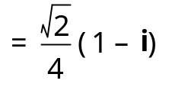 ← Rectangular form ✓

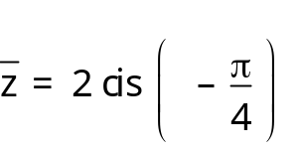 ← Polar form ✓
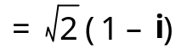 ← Rectangular form ✓

- [2, 2, 2, 2 = 8 marks]
The Argand diagram below shows the point representing the complex number z where | z | > 1. Plot on the same diagram, the points representing the complex numbers:
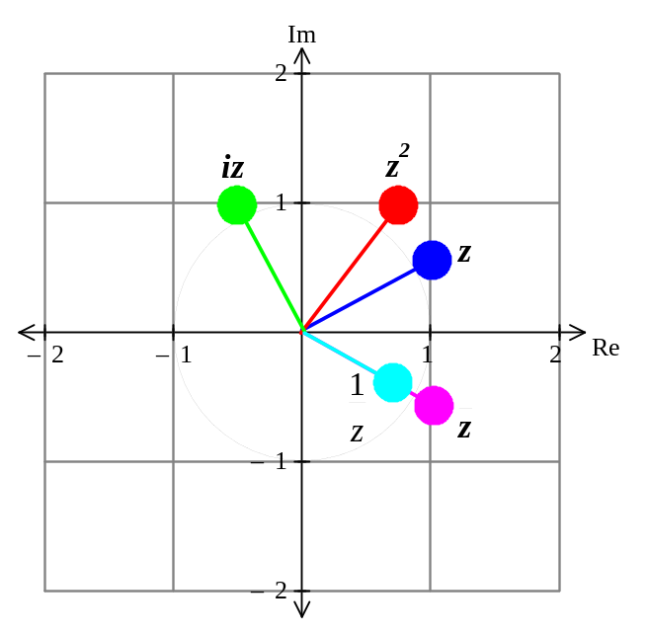a) b) iz c) z² d)

If z = 1 + ½i
⇒ = 1 – ½i
✓✓
iz = -½ + i
✓✓
z² = ¾ + i
= (1 – ½i)
✓✓
✓✓

- [3, 3, 3, 3 = 12 marks]
Sketch on an Argand diagram, the locus of the point z = x + iy, satisfying each of the following conditions. In each case, give the Cartesian equation or inequality of the locus.
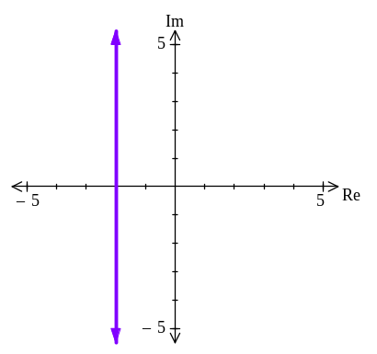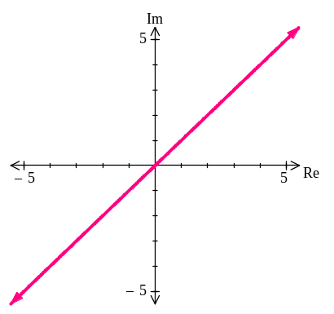a) Re(z) = -2 ⇒ x = -2 ✓ b) Im(z) = Re(z) ⇒ y = x ✓

✓✓ ✓✓

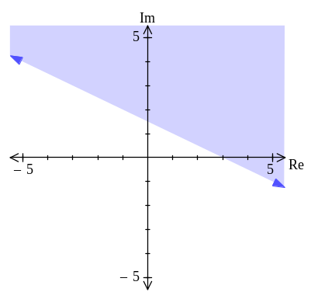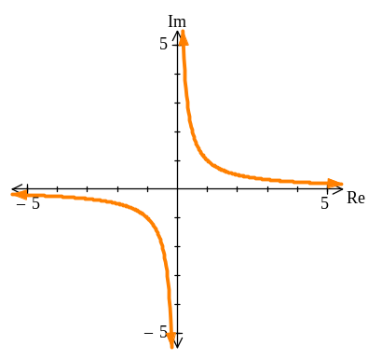c) Re(z) + 2Im(z) > 3 ⇒ x + 2y > 3 ✓ d) Re(z).Im(z) = 1 ⇒ xy = 1 ✓

✓✓ ✓✓

